# PAW

Transforming the regular crutches to PAW which would require less body effort and would act as your escort while you wander around. A mobility aid that eliminates the abnormal walking style of the crutches.

### **DESIGN TASK CLARIFICATION**

"Redesign Crutches to reduce use and effort of hands and underarms of user, keeping conformance to the definition of crutches."

### THE CONCEPT SOLUTION

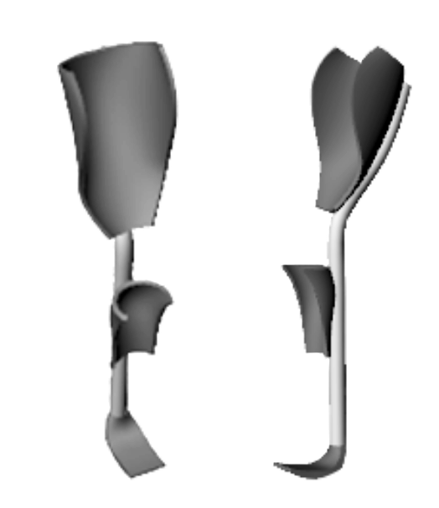

### PROTOTYPE

# Chatur – The Silencer

The project was done as a part of a competition, **"Techgium 2018"**. The product was proposed against a challenge statement as given below. We were a team of two students, Shivam Sharma and myself from IIT Roorkee.

## Challenge Statement

To develop an active noise cancellation system for automobile muffler.

Discussing with stakeholders and the project mentors, the challenge statement was formulated into following functional requirements:

• Redesign existing muffler  
• Destructive interference causes attenuation of exhaust noise  
• Compact muffler system  
• Efficient sound control system

## Concept Development

[More design information restricted]

Prototype, experiment testings and proof of concept led us to the top 6 teams in the competition of 9000 teams who registered.

# Bumblebee Dock station

### Problem

* The charging cable couldn't be fixed anywhere to avoid finding it everytime you want to charge your phone.
* Watching some video, scrolling through texts, quick "OK Google" searches etc. while working on PC are not so convenient when phone is lying flat on your desk.
* I got a new phone. I ought to give some respect! Can't just leave it around randomly with the charging wire up its butt. That's obscene.

### Design

The design is modeled in Fusion360 and 3D printed using PLA on a FDM machine.

# IIT Memento

## two v7

## CONCEPT:

The use of wormhole is to portray how IIT Roorkee aims to offer the students a chance to develop technical competence and compete at a global level through knowledge and innovation. Since a wormhole is the shortest path between two points in space, it's being used to show how this institute is the shortest way to transform oneself both technically and professionally. The past is when the student enters the institute and the future is how he leaves as a better form of himself.

## DESIGN KEY POINTS:

* Minimal design of the memento requires less use of material to say more.
* The design reflects the capability of 3-D printing to prototype and manufacture complex geometries.
* It shows the technological advancements of the tinkering lab and the role it plays in the transformation of the populace of IIT Roorkee.

## Achievements

* We successfully fabricated it using 3D Systems Project MJP 3600 with Visijet M3-Crystal.
* Of all 20 submissions and 10 prototypes, we were able to secure a **second rank** in the institute.

# KPT Pipes

A consultancy project to IIT Roorkee by a private firm which is one of the leading supplier of PPR (Polypropylene Random) based pipes and fittings. The problem statement as per the project agreement was to "Design three concepts of 32 mm pipe straight joints with minimal extra projections radially".

I was successful in designing and prototyping 3 concepts and then helping the firm finalizing one of the designs for further development. One of the designs (assembled) is shown below with the prototype below.

[....Further information restricted]

[gallery ids="141,148" type="rectangular"]

Major part of designing and prototyping was done in [Rethink - The Tinkering Lab](https://www.iitr.ac.in/tinkeringlab/), IIT Roorkee under the supervision of [Dr. Inderdeep Singh](https://www.iitr.ac.in/~ME/inderfme) (Associate Professor, MIED, IIT Roorkee)

# Bat-Tie

A self-assigned project to gift my gang (J2B) an identity, and something to remember for lifetime. Everyone getting ready for the final farewell photo-shoot of Batch 2018, this was a cherry on the cake to differentiate our frat from the batch.

[gallery ids="115,118,113,112" type="slideshow"]

## 

## Design Description

The Nolan style Batman logo was created on photoshop and converted to sketch in Fusion 360 to make a 3D Model, and further print it using Ultimaker 2.0 with ABS Black. The bat is attached to a button clip using adhesive which hangs to the collar button. The button clip was also designed in Fusion 360 and printed further in Ultimaker 2.0 with ABS white.

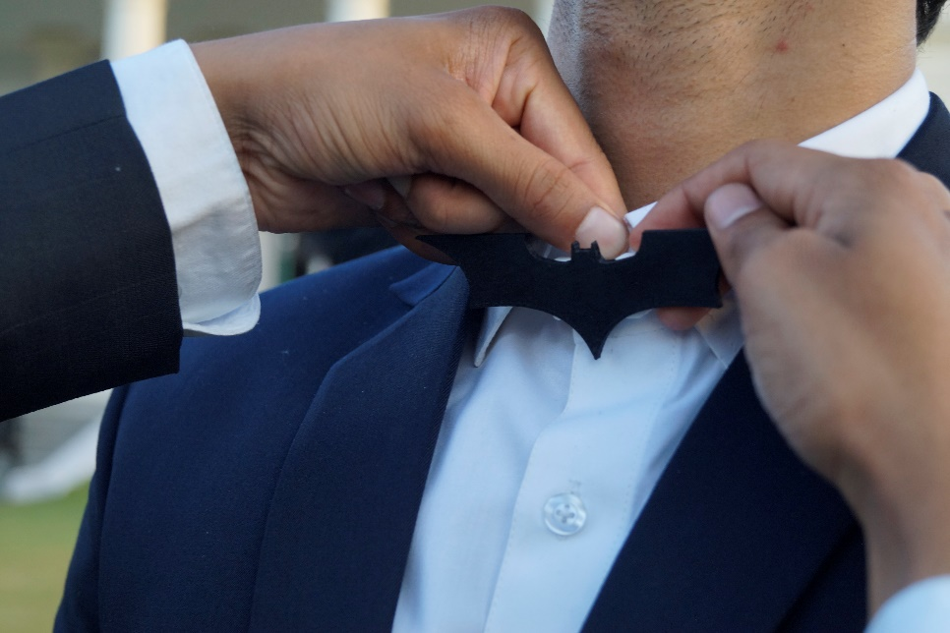

# Acoustic Metamaterials

A metamaterial is an artificial material whose material properties emerge due to its structure, rather than the properties of the material from which the metamaterial is made.

Many features and applications of acoustic metamaterials, such as guiding waves along specified paths in three-dimensional space, frequency filtering, and focusing or slow-  
ing down waves propagating through the crystal. This work focuses only on the **frequency bandgap properties**.

Objective was to come up with a flexible module to generate lattice structure with desired frequency bandgap. The module presented here to satisfy above is **BEA**.

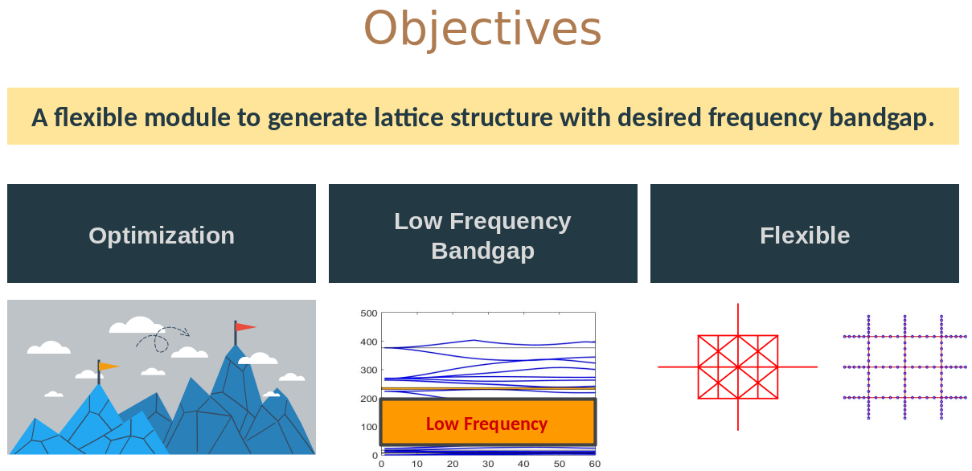

## Band-gap Evolutionary Approach (BEA)

The algorithm, based on genetic algorithm, optimizes the unit cell structure of a periodic lattice with the aim to maximize the band gap percentage.

A designer would be able to use it to design and synthesize a acoustic metamaterial with  
desired bandgap ranges of in-plane waves and make BEA a handy tool in the process.

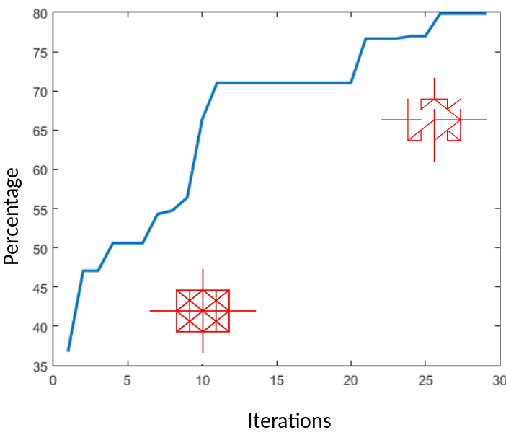The graph shows increase in percentage with number of iterations of BEA. For the particular unit cell (in red), the target frequency range is 100 Hz - 150 Hz. One of the final designs in shown on top right (in red).

## Results

* The BEA algorithm has proven to be very successful in producing nearly perfect bandgap in the specified frequency range, and complete 100 % bandgap in few cases.
* For a small frequency ranges (12 kHz - 13 kHz, 15 kHz - 20 kHz) BEA has shown to  
  produce 100 % bandgap and beyond.
* The simplistic approach of BEA, being on the tracks of evolutionary optimization,  
  gives it the advantage of making the optimization problem modular. That is, the  
  calculation of eigen value problem and FEM remains exclusive from the optimization routine, and is only interfering as the fitness function value.
* The above also gives it the advantage of optimizing aggregate bandgaps between the frequency range
* With a particular unit cell as input, BEA gives a range of final designs. This gives the designer a choice, who can now consider other strutural parameters as well before selecting the lattice for his applications.

[Complete Thesis Link](https://drive.google.com/file/d/1I2tYob1-xULNHC__Ihnc4NypGtkFvDPh/view?usp=sharing)

# InDeaTe

Design research involves studying and improving the process of design. [**InDeaTe tool**](https://link.springer.com/chapter/10.1007/978-981-10-3521-0_24) is a result of research into this field. It is a computer aided design tool which empowers designers to design products, manufacturing systems and service systems using a database of design methods, tools, and sustainability definitions & indicators at different design stages under a well-researched framework.

**The internship was to research and develop the database for the tool. Learn and research different design methods for product and manufacturing systems, and create the database.**

The definitions of design stages are necessary to help identify the status of the design of a product/system. Pahl and Beitz's model of design process is adopted by InDeaTe for its framework.

[caption id="attachment_128" align="alignnone" width="415"]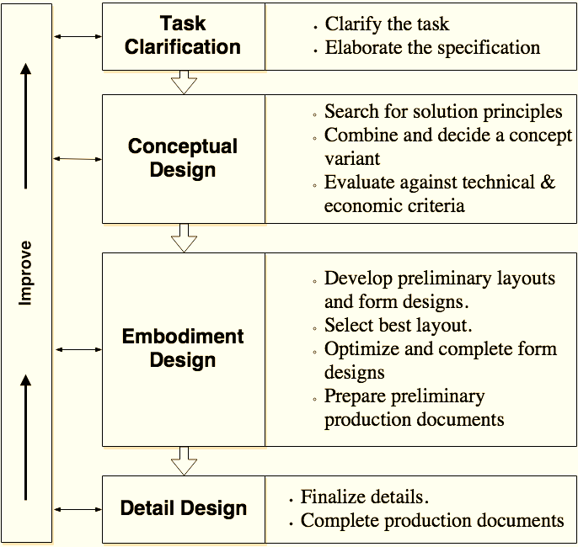 Pahl and Beitz’s model of design process.[/caption]

### Sustainability

Three pillars of sustainability states that sustainability of a design can be judged on three grounds, i.e., environment, economy, and society.

InDeaTe features definitions and indicators of sustainability based on above model. Sustainability can quantified using appropriate parameters or indicators. This helps designer ideate and consider sustainable solutions in more efficient way.

### Design Methods

Design methods provide a structured approach and guidelines during different stages of design to deliver required output. Some of these may be to gain key insights, to get appropriate and acceptable mindset and constraints or provide a holistic approach in order to achieve better user experience with products, systems or services.

InDeaTe feature hundreds of such methods under its framework for each stage, problem type and domain.

## Learning from Internship!

1. Conducted and attended *IUSSTF Dissemination Workshop on Design of Sustainable Systems.*
2. Design methods/tools
3. Principles of sustainability.
4. Design approach to problem-solving.
5. Elements of manufacturing systems and its design.

# ESA

We developed a methodology with **Tata Steel R&D Department** that converts Life Cycle Assessment (LCA) results into a single indicator, named **Environment Sustainability Index (ESI),** enabling easy decision making. ESI converts LCA results into a single indicator which is in a scale of 1 to 5, 1 being the worst and 5 being the best.

## Problem Statement

Develop a tool for converting Life Cycle Assessment results to a single indicator, enabling easy decision making

**Even though LCA is a robust tool, it's challenging to interpret the results**

## Concept and Framework

[caption id="attachment_135" align="alignnone" width="1338"]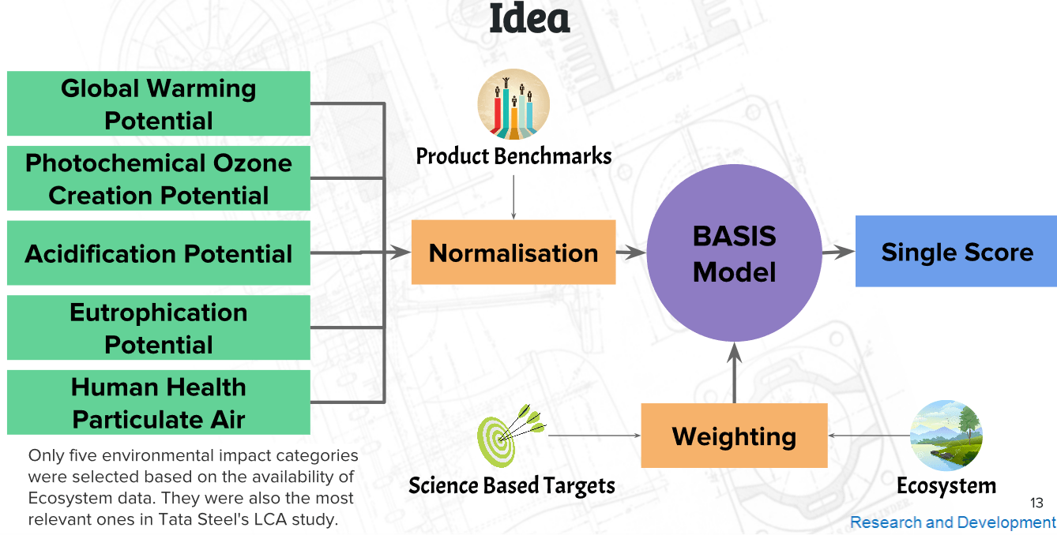 ESI basic framework and implementation[/caption]

### Key Points

* Distance-to-target approach used
* Targets chosen have scientific basis
* Considers the "difficulty" to achieve the target
* Historic trends of impact categories considered

Impact of ESI on different users[/caption]

# GPU Computing

GPU parallelization is implemented at the level of molecular movement and inter-molecular collisions in existing dsmcFoam solver (Direct Simulation Monte Carlo solver offered by openFoam). The accuracy, efficiency and feasibility of the GPU implementation in dsmcFoam is analysed in this project.

GPU offers thousands of small cores which result in significant acceleration by offloading compute-intensive portions of the code to the GPU while the remainder still runs on the CPU. They were originally designed for computer graphics, but now are increasingly used to improve the performance of scientific and engineering applications, also called **GPGPU (General-Purpose computation on Graphics Processing Units).**

Further details of implementation and results could be found in the paper as linked [here](https://drive.google.com/file/d/1rJvqblFdFR453cvfKVNhWDVjNLcJ-Wpz/view?usp=sharing).

# P-VEDA

**P-VEDA** (Polarised Vision for Enhanced Driving Assistance), as an innovative solution to reduce headlight glare on roads.

### Introduction

Driving an automobile is primarily a visual task, and vision contributes as much as 90% of the information needed to drive. Artificial lighting can illuminate the roadway, but too much light or improper lighting may result in **glare**, which causes **visual discomfort** and **a diminished ability** to see the environment.

### Polarized Vision for Enhanced Driving Assistance (P-VEDA)

It’s a complete solution to headlight glares on the roads. With P-VEDA, you don’t get glare caused by approaching vehicle as it is almost 100% cancelled due to the polarized setting (as shown in figure 1), but the objects illuminated by the vehicle is clearly visible to its driver.  
The purpose of headlights is to allow its driver to have an illuminated view of approaching surroundings. It doesn’t stands of no use to other drivers other than indicating vehicles presence on road. PVEDA, in a way, acts as a smart filter to block those headlights but allow only those lights to reach which assists the driver.

**Schematic explaining how light of car #2 is not visible to driver #1 but objects illuminated by car #1 headlights are easily visible to driver #1. Each polarizer is oriented at about 45 degrees.**

[Full Report](https://drive.google.com/file/d/1N8IZeTgPohmWuGbcBZrZFtsGLj99Rn9E/view?usp=sharing)